Lesson 1 A private conversation私人谈话
First listen and then answer the question.
听录音，然后回答以下问题。
Why did the writer complain to the people behind him?
Last week I went to the theatre. I had a very good seat. The play was very interesting. I did not enjoy it. A young man and a young woman were sitting behind me. They were talking loudly. I got very angry. I could not hear the actors. I turned round. I looked at the man and the woman angrily. They did not pay any attention. In the end, I could not bear it. I turned round again. 'I can't hear a word!' I said angrily.
'It's none of your business,' the young man said rudely. 'This is a private conversation!'
New words and expressions 生词和短语
private adj. 私人的
conversation n. 谈话
theatre n. 剧场，戏院
seat n. 座位
play n. 戏
loudly adv. 大声地
angry adj. 生气的
angrily adv. 生气地
attention n. 注意
bear v. 容忍
business n. 事
rudely adv. 无礼地，粗鲁地
参考译文
上星期我去看戏。我的座位很好，戏很有意思，但我却无法欣赏。一青年男子与一青年女子坐在我的身后，大声地说着话。我非常生气，因为我听不见演员在说什么。我回过头去怒视着那一男一女，他们却毫不理会。最后，我忍不住了，又一次回过头去，生气地说：“我一个字也听不见了！”
“不关你的事，”那男的毫不客气地说，“这是私人间的谈话！”
Lesson 2 Breakfast or lunch?早餐还是午餐？
First listen and then answer the question.
听录音，然后回答以下问题。
Why was the writer's aunt surprised?
It was Sunday. I never get up early on Sundays. I sometimes stay in bed until lunchtime. Last Sunday I got up very late. I looked out of the window. It was dark outside. 'What a day!' I thought. 'It's raining again.' Just then, the telephone rang. It was my aunt Lucy. 'I've just arrived by train,' she said. 'I'm coming to see you.'
'But I'm still having breakfast,' I said.
'What are you doing?' she asked.
'I'm having breakfast,' I repeated.
'Dear me,' she said. 'Do you always get up so late? It's one o'clock!'
New words and expressions 生词和短语
until prep. 直到
outside adv. 外面
ring v. （铃、电话等）响
aunt n. 姑，姨，婶，舅母
repeat v. 重复
参考译文
那是个星期天，而在星期天我是从来不早起的，有时我要一直躺到吃午饭的时候。上个星期天，我起得很晚。我望望窗外，外面一片昏暗。“鬼天气！”我想，“又下雨了。”正在这时，电话铃响了。是我姑母露西打来的。“我刚下火车，”她说，“我这就来看你。”
“但我还在吃早饭，”我说。
“你在干什么？”她问道。
“我正在吃早饭，”我又说了一遍。
“天啊，”她说，“你总是起得这么晚吗？现在已经1点钟了！”
Lesson 3 Please send me a card请给我寄一张明信片
First listen and then answer the question.
听录音，然后回答以下问题。
How many cards did the writer send?
Postcards always spoil my holidays. Last summer, I went to Italy. I visited museums and sat in public gardens. A friendly waiter taught me a few words of Italian. Then he lent me a book. I read a few lines, but I did not understand a word. Everyday I thought about postcards. My holidays passed quickly, but I did not send cards to my friends. On the last day I made a big decision. I got up early and bought thirty-seven cards. I spent the whole day in my room, but I did not write a single card!
New words and expressions 生词和短语
send v. 寄，送
postcard n. 明信片
spoil v. 使索然无味，损坏
museum n. 博物馆
public adj. 公共的
friendly adj. 友好的
waiter n. 服务员，招待员
lend v. 借给
decision n. 决定
whole adj. 整个的
single adj. 唯一的，单一的
参考译文
明信片总搅得我假日不得安宁。去年夏天，我去了意大利。我参观了博物馆，还去了公园。一位好客的服务员教了我几句意大利语，之后还借给我一本书。我读了几行，但一个字也不懂。我每天都想着明信片的事。假期过得真快，可我还没有给我的朋友们寄过一张明信片。到了最后一天，我作出了一项重大决定。我早早起了床，买来了37张明信片。我在房间里关了整整一天。然而竟连一张明信片也没写成
Lesson 4 An exciting trip激动人心的旅行
First listen and then answer the question.
听录音，然后回答以下问题。
Why is Tim finding this trip exciting?
I have just received a letter from my brother, Tim. He is in Australia. He has been there for six months. Tim is an engineer. He is working for a big firm and he has already visited a great number of different places in Australia. He has just bought an Australian car and has gone to Alice springs, a small town in the centre of Australia. He will soon visit Darwin. From there, he will fly to Perth. My brother has never been abroad before, so he is fending this trip very exciting.
New words and expressions 生词和短语
exciting adj. 令人兴奋的
receive v. 接受，收到
firm n. 商行，公司
different adj. 不同的
centre n. 中心
abroad adv. 在国外
参考译文
我刚刚收到弟弟蒂姆的来信，他正在澳大利亚。他在那儿已经住了6个月了。蒂姆是个工程师，正在一家大公司工作，并且已经去过澳大利亚的不少地方了。他刚买了一辆澳大利亚小汽车，现在去了澳大利亚中部的小镇艾利斯斯普林斯。他不久还将到达达尔文去，从那里，他再飞往珀斯。我弟弟以前从未出过国，因此，他觉得这次旅行非常激动人心。

Lesson 5 No wrong numbers无错号之虞
First listen and then answer the question.
听录音，然后回答以下问题。
What does 'No wrong numbers' mean?
Mr.James Scott has a garage in Silbury and now he has just bought another garage in Pinhurst. Pinhurst is only five miles from Silbury, but Mr. Scott cannot get a telephone for his new garage, so he has just bought twelve pigeons. Yesterday, a pigeon carried the first message from Pinhurst to Silbury. The bird covered the distance in three minutes. Up to now, Mr.Scott has sent a great many requests for spare parts and other urgent messages from one garage to the other. In this way, he has begun his own private 'telephone' service.
New words and expressions 生词和短语
pigeon n. 鸽子
message n. 信息
cover v. 越过
distance n. 距离
request n. 要求，请求
spare part 备件
service n. 业务，服务
参考译文
詹姆斯.斯科特先生在锡尔伯里有一个汽车修理部，现在他刚在平赫斯特买了另一个汽车修理部。平赫特离锡尔伯里只有5英里，但詹姆斯.斯科特先生未能为他新的汽车修理部搞到一部电话机，所以他买了只鸽子。昨天，一只鸽子把第一封信从平赫特带到锡尔伯里。这只鸟只用了3分钟就飞完了全程。到目前为止，斯科特先生从一个汽车修理部向另一个发送了大量索取备件的信件和其他紧急函件。就这样，他开始自己的私人“电话”业务。
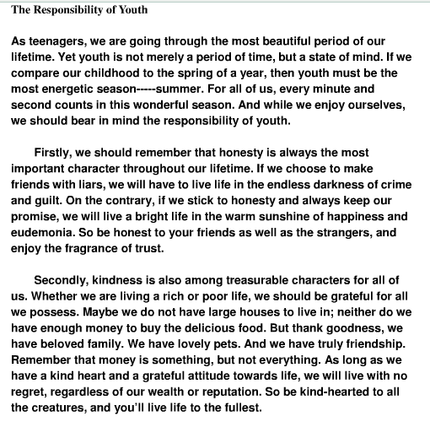
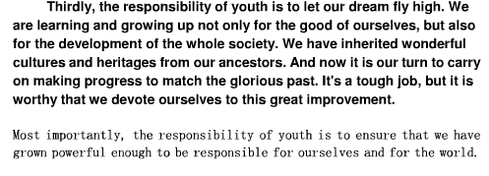
There are many responsibility of youth. Youth is responsible to build the nation. Youth is responsible to make the society good and noble . Youth can improve the community and culture of society . If youth understands his responsibility , a large number of crime may reduce with in one day. In India we need responsible youth . We do not need careless youth . We do not need drunken youth . We do not need indifferent youth . We do not need reckless youth . Because these type of youth weaks our country. A responsible youth is better than 100 careless youth . Careless youth do not understand his responsibility . He is not entitled for any credit . Youth's responsibility makes youth perfect if he perform his responsibility . Many people need the help of youth but youth do not care of this and after this so many mishappening is happen on carelessness of youth .
I am here giving the main responsibilities of youth .
1. Value of time →
It is the responsibility of youths to identify the value of time . Because every moment of youth is very costly . Youth should be punctual for doing every work.
2. Stick to high ideals →
Our saints have fixed good ideals for human being. It is the responsibility of youth that he has to stick all high ideals .
3. Discipline →
It is responsibility of youth to maintain discipline because youth have passion . They misuse their passion by creating indiscipline. With indiscipline we can not make our country great . So , youth must understand the importance of discipline.
4. Tolerance →
I often saw that youths are so hurry to get result of his work . It is the responsibility of youth to do every work with tolerance . They should wait and they should present as a example of patience for others . They should learn tolerance from shri Ram Chandra when his father order him to go to forest for 14 years . He accepted this order patiently and wait 14 years for returning back to home . His responsibility is also an example for all youths .
5. Think before action →
Youths have stopped thinking . But he should know that this is main responsibility to think before action . With doing this youths can make thoughtful society . They can create original thinking . Thinking is differ from cramming . Thinking develop the mind of society but cramming ceases to be capable of original thinking.
6. Defend the freedom of country →
We are the citizens of free India . We got this freedom 62 years back . Countless freedom fighters struggled for achieving it . They sacrificed themselves so that we may hold our head high in respectful manner . It is the responsibility of youths of India to defend this freedom at every cost .

